**Software Requirement Specification**

**---ChargEazy---**

**Problem Statement**

The need for a web application that shows the area of EV charging stations close by is increasing as the quantity of electric vehicles out and about increases. Since the scope of electric vehicles is restricted, it's basic for drivers to have the option to rapidly find charging stations while they're making the rounds. A web application that shows clients a continuous guide of neighboring charging stations can help vehicles in doing this.

Drivers of electric vehicles can profit from a web application that shows the area of neighboring EV charging stations. With its help, they can recognize charging stations rapidly and essentially, and it can arm them with the data they need to settle on an educated conclusion about a charging technique.

**Scope**

Clients may likewise approach different administrations through the web application, for example, the ability to save their favored charging areas, find a charging website, and hold a charging time ahead of time. With these highlights, charging stations might be simpler to find and utilize, making it more probable that clients won't run out of force.

Other data about charging focuses, for example, the sort of charging point, the expense of charging, and the accessibility of the charging point, can likewise be given utilizing the web application. Drivers can involve this data to choose the ideal charging station for their need.

**Functional Requirements**

The app must allow users to search for EV charging points by location. The search should allow users to specify the following criteria:

* The type of charging point (e.g., public, private, fast, slow)
* The price of charging
* The distance from the user's current location
* The availability of the charging point
* The app must display the location of each charging point on a map. The map should be interactive, allowing users to zoom in and out and pan around.
* The app must display the status of each charging point (e.g., available, occupied, inoperable).
* The app must display the price of charging at each point.
* The app must allow users to filter the results by type of charging point (e.g., public, private, fast, slow).
* The app must allow users to save their favorite charging points. The app should allow users to create a list of their favorite charging points, which they can then access quickly and easily.
* The app must allow users to get directions to a charging point. The app should provide users with turn-by-turn directions to the nearest charging point.

**Non-Functional Requirements**

* The app must be available 24/7. The app should be accessible to users at any time of day or night.
* The app must be responsive and load quickly. The app should not take more than a few seconds to load, even on slow internet connections.
* The app must be secure. The app should protect users' personal information from unauthorized access.
* The app must be accessible to users with disabilities. The app should be designed to be accessible to users with disabilities, such as those who are blind or visually impaired.
* The app must be compatible with all major browsers. The app should work on all major web browsers, such as Chrome, Firefox, and Safari.

**Potential Users of the Web App**

Drivers: Drivers can use the web app to find charging points when they are on the go. They can also use the web app to get directions to a charging point, and to book a charging spot in advance.

Businesses: Businesses that offer EV charging can use the web app to promote their charging points to drivers. They can also use the web app to track the usage of their charging points and to manage their reservations.

Government agencies: Government agencies can use the web app to collect data about EV charging usage. They can also use the web app to promote EV charging and to encourage drivers to switch to electric vehicles.

Charging point operators: Charging point operators can use the web app to manage their charging points. They can use the web app to track the usage of their charging points, to receive payments, and to provide customer support.

EV enthusiasts: EV enthusiasts can use the web app to learn about EV charging and to find charging points in their area. They can also use the web app to share tips and advice about EV charging.

**Use-Cases of the Web App**

A driver is on a road trip and needs to find a charging point. They use the web app to search for charging points in their area and to get directions to the nearest one.

A business owner wants to promote their EV charging points to drivers. They use the web app to create a listing for their charging points and to set up a reservation system.

A government agency is collecting data about EV charging usage. They use the web app to collect data from charging point operators and to track the usage of charging points over time.

A charging point operator wants to manage their charging points. They use the web app to track the usage of their charging points, to receive payments, and to provide customer support.

An EV enthusiast wants to learn about EV charging. They use the web app to read articles about EV charging and to find charging points in their area.

**Additional Requirements**

The app should use open data sources to populate its database of charging points. This will ensure that the app is always up to date with the latest information about charging points.

The app should be regularly updated with new charging points. This will ensure that users always have access to the most accurate information about charging points.

The app should be user-friendly and easy to navigate. The app should be designed in a way that is easy for users to understand and use.

**Entity details**

Entities:

1. User: Represents the app's users.
   * Attributes: UserID (Primary Key), Username, Email, Password, CurrentLocation (Latitude, Longitude), etc.
2. Charging Station: Represents EV charging stations.
   * Attributes: StationID (Primary Key), StationName, Location (Latitude, Longitude), Address, ChargingCapacity, Status (Available, Occupied, Out of Order).
3. Charging Provider: Represents companies or organizations that own or operate charging stations.
   * Attributes: ProviderID (Primary Key), ProviderName, ContactInfo, Website.
4. Review: Represents user reviews for charging stations.
   * Attributes: ReviewID (Primary Key), UserID (Foreign Key), StationID (Foreign Key), Rating, Comment, Timestamp.

Relationships:

1. User-Location (1-to-1):
   * A user has one current location.
   * A current location belongs to one user.
2. User-Search (1-to-Many):
   * A user can perform multiple charging station searches.
   * Each charging station search is associated with one user.
3. User-Review (1-to-Many):
   * A user can write multiple reviews.
   * Each review is written by one user.
4. Charging Station-Provider (Many-to-1):
   * Many charging stations are provided by one charging provider.
   * Each charging station is associated with one charging provider.
5. Charging Station-Review (1-to-Many):
   * A charging station can have multiple reviews.
   * Each review is associated with one charging station.
6. User-Station (Many-to-Many):
   * A user can save multiple charging stations as favorites.
   * A charging station can be saved as a favorite by multiple users.
7. User-SearchResult (Many-to-Many):
   * A user can find multiple charging stations in a search.
   * A charging station can be found in multiple user searches.

**ER Diagram**

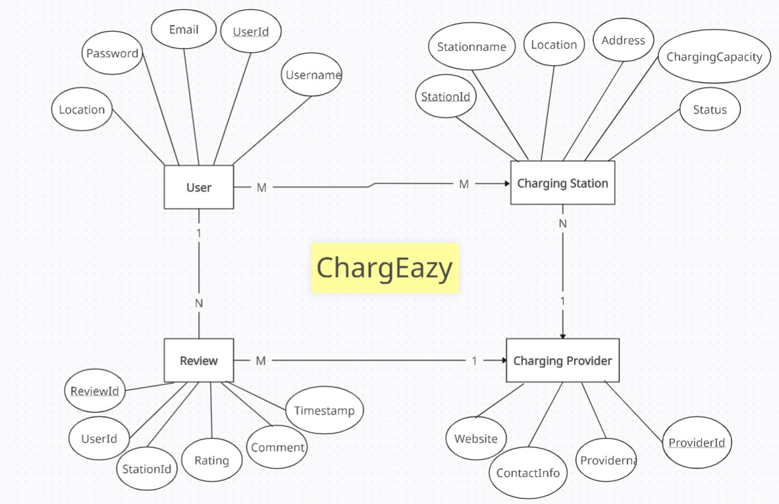

**Use Case Diagram**

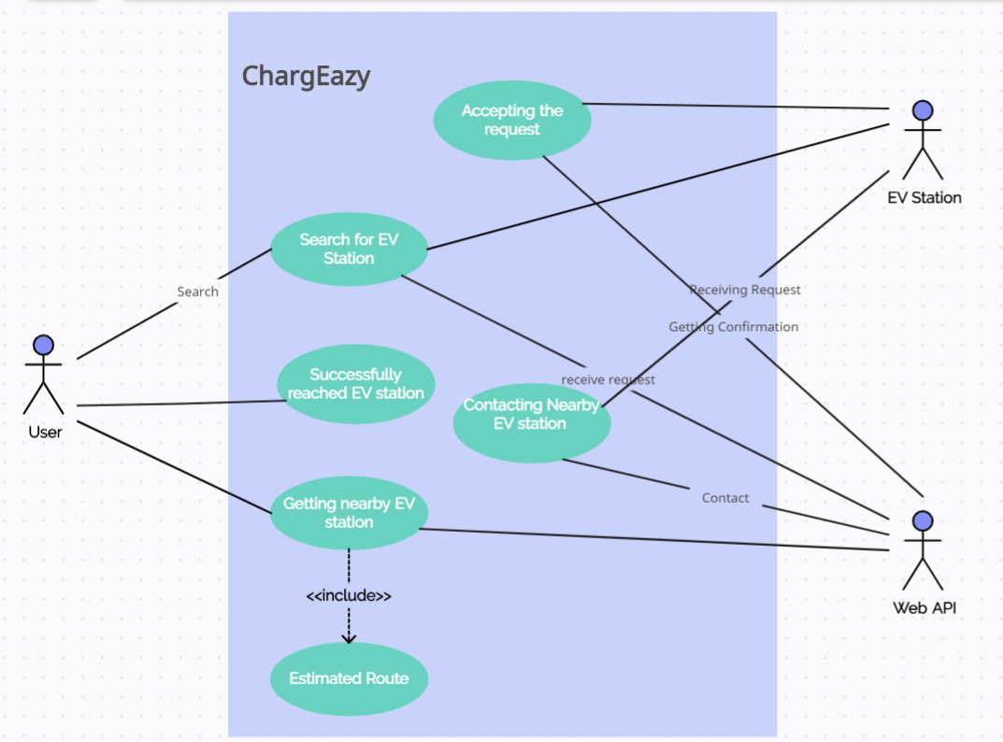

**Sequence Diagram**

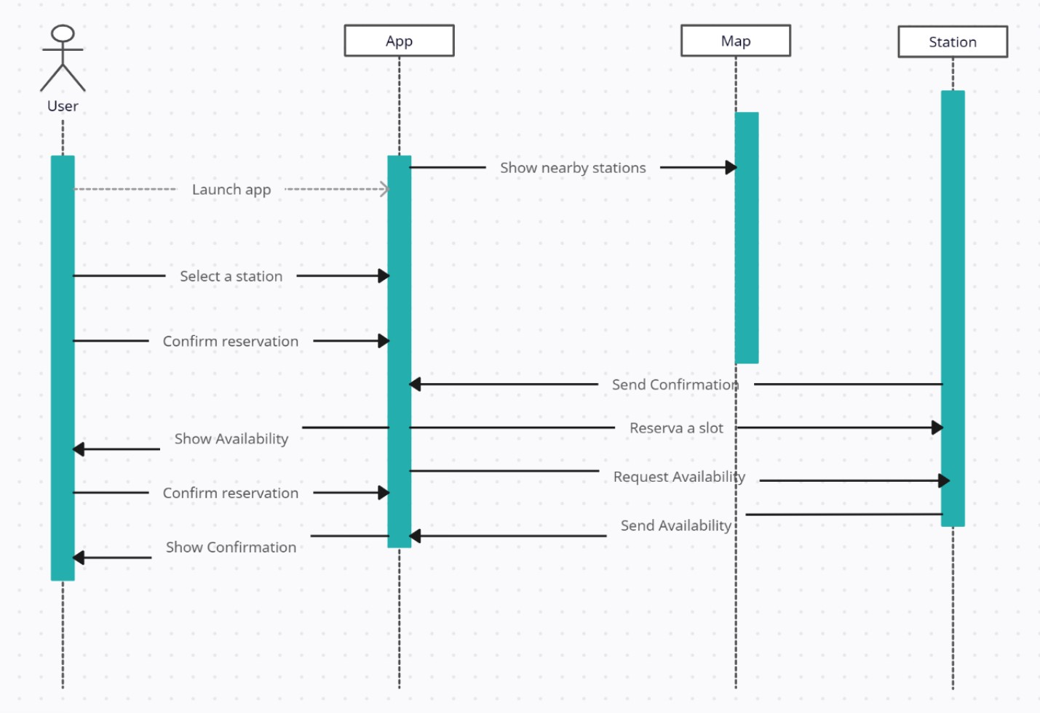

**Hardware details**

* **Laptop (min. requirements – 2GB RAM, Intel i3 processor)**
* **Mobile phone**

**Software details**

* **Web browser (Chrome/Safari/Mozilla Firefox/Opera)**
* **Min. requirements (mobile phone) – android 7 or ios 15**
* **Min. requirements (laptop) – Windows 10, macOS Catalina, Linux**